MIMO A-3 Customer Transfers + Owner Allocation Minutes
6.4.2026 |  | 9:00AM – 12:00PM EST
Team | Service Cloud Team
Facilitators | Mohanta Das
Note taker | Taylor
Attendees | Service Cloud, WAM
Notes:
Decisions
Action Items
Change Impacts
Open Discussion Items

See full notes below
- Owner Allocation / Tenant:
- Creation of Multiple Owners (using a transaction launcher à this will need to be a backend process?)
- Change Impact: CSR’s using front end currently, so this will be a back end process
- Connection object or installation object
- Dawn’s Idea of using Multiple premises?
- Current state has no process automatically creating Owner Allocation in current state
- Calling from S/4
Action: Taylor schedule dedicated follow up discussion here to make the actual decision
(include core team+ Chris Elliot+ who else?

Notes from Workshop
Using Transaction launcher /Mashup for Creating Owner Allocation since it needs to launch to the backend + Mass Creation of Owners
Need
Dawn’s idea of using the multiple premises option
Mass Creation of Owners
Is connection object or installation object
Nammi checking owner allocation workflow if contract account is created
Need Chris Elliot on Follow Up call.

Notes from Workshop:
CSRs using front end currently, so this will be a back end process à change impact ?
There is no process automatically creating Owner Allocation in current state
If the owner exists it moves them in.

Chris Elliot’s note for Creating Multiple under the Premise object
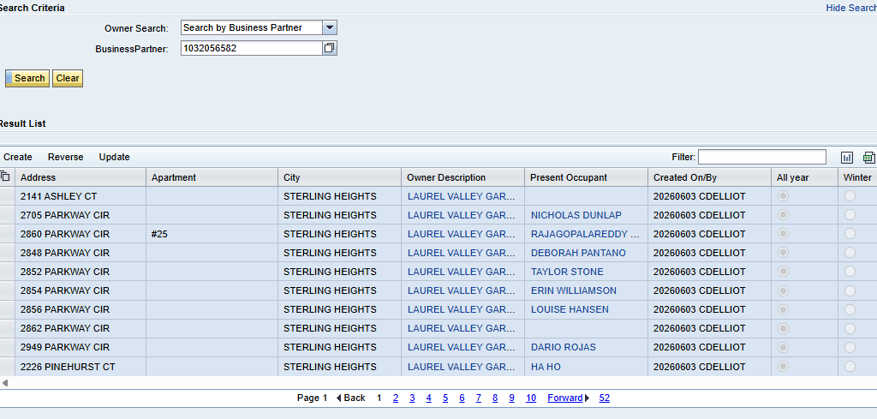

Manual Owner Allocation à need to show how this in future state CRM7
~~~~~~~~~~~~~~~~~~~~~~~~~~~~~~~~~~~~~~~~~~~~~~~~~~~~~~~~~~~~~~~~~~~~~~~~~~~~~~~~~~~~~~~~
- Contract Account Creation
Option to create by premise or installation object
Current process automatically, creates a contract account in the background
This will be a customization in the future state
Owner Creation – contract
Requirement to have a contract account
Contract accounts are not generated until the Customer moves in for the first time.
Action: Contract Account shows in the back end - we can test that to show or be sure but it has always worked that way

Ensure Contract account decision is cloes
~~~~~~~~~~~~~~~~~~~~~~~~~~~~~~~~~~~~~~~~~~~~~~~~~~~~~~~~~~~~~~~~~~~~~~~~~~~~~~~~~~~~~~
Starting at BP level instead of starting at Premise level? Taylor Update RIDA in ADO
~~~~~~~~~~~~~~~~~~~~~~~~~~~~~~~~~~~~~~~~~~~~~~~~~~~~~~~~~~~~~~~~~~~~~~~~~~~~~~~~~~~~~~
Decision: For Transfer of Service, all the same requirements in Move In and Move Out will have the same requirements for Transfer of Service Screens

Should be able to specify move in and move out date separately

- Submitting Transfers – Do Move in then Move Out sow e don’t have to transfer to the back end
Submit Move In /Out/Transfers à success/ failure message, back end process, likely change impact
Move out first then move in, automatically transfers CARE and SPP forward
à if we do this process for transfers, then the process in the backend for CARE won’t work
Workflow that tranfers CARE program to active account
Need to check what is triggering this workflow

In Service Cloud these do happen at the same time à so this won’t work in future state

Do Move Out, then Do Move In so we don’t have to the transfer to the backend
Transfer of Service will be a brand new process

- Hide the transfer button, based on Customer Class (not based on User)
Nammi is saying it is not Out of the Box, so this will be an enhancement (not sure if an enhancement is even possible),

(5) Move In Questions Related to Transfers
Caleb’s Question on Pre Move In Questions related to Transfers
Don't need to discuss now but can the pre move in screen questions from the previous account auto fill during a transfer? Particularly if customer is moving from a combo to a combo, it can be assumed (I know, I know, what assuming does) that the customer will still utilize gas for heat, and the same electric rate etc. and run facta somewhat in the background. Does that make sense what I am saying?
There should be an existing ADO task related to Transfers

- Option to specify two mailing addresses- one for move in one for Move out on Contract account and Billing Screen
Option to specify two mailing addresses- one for move in one for Move out – Taylor add to existing ADO Item, Mohanta to check with Balaji
à creating multiple addresses in same screen, we need to check with SAP

We will be creating multiple addresses and tons of wasted data records
- Hard Stop- need to move earlier in the transfer process to have earlier validation before the MDT Button
Next button customer and premise, if we can stop Move In and Transfer à adding validation as alert or warning if the CSR can move forward- either a hard stop or a warning by alert
- Need to ask Balaji if we can add Validation before submit MDT
Right now it is a hard stop vs if they can override.
Can we move hard stop earlier in in the transfer process so there is earlier validation before MDT button

We will remove Submit and Keep Submit via MDT for Tranfers

Move in/ move out/ transfer summary autopopulating for each of the three process. Need to have it as a list

Removing Joint Invoicing Field completely – Stephanie’s request for billing team

Cover this during Alerts workshop – Taylor add in ADO
Can we create an alert for senior customer à Customer specific cannot be done for transfer, but it can be done as role based à these are explore POCs that we need to cover
- Need to start this as soon as possible.

Update fields associated with Premise à Taylor update in ADO

Taylor update WRICEF List with this from NAMMI
Repurpose same development for move in move out as part of the transfer

